**Achieve Fault tolerant, HA, Resilience and Auto scaling using AWS services in application**

**Use case:** We have a web application and want to achieve High availability, Fault tolerance, Auto scaling and load balancing using AWS cloud provider’s services.

**Below are the steps to create and configure all required AWS services to achieve above functionality:**

Step#1: Create a S3 bucket to keep latest code

Step#2: Create a public S3 bucket to store media files

Step#3: Create a cloud front distributions using domain name of media s3 bucket

Step#4: Create a security group for EC2 instances to provide access on port 80

Step#5: Create a security group for RDS instances to provide access on port 3306 and 80

Step#6: Create a MySQL/Aurora instance with multi AZ feature and RDS security group

Step#7: Create a role for EC2 instances to provide S3FULLACCESS

Step#8: Create an EC2 instance with above role and bootstrap script (steps to install all pre-requisites)

Step#9: Configure word press application with MYSQL through EC2

Step#10: Create a post on word press site with some media files i.e. images

Step#11: Copy word press code to S3 bucket to use it later in Auto scaling

Step#12: Update .htaccess to rewrite URL of media images in word press with cloud front URL and httpd.conf to allow rewrite URL

Step#13: Restart httpd service to reflect the above changes

Step#14: Create crontab to sync S3 bucket code from EC2 instance and s3 media bucket from word press media. Restart crontab service.

Step#15: Create EC2 image to use it later

Step#16: Create EC2 instance using above created image and bootstrap script of syncing word press code from S3 bucket

Step#17: Create Auto scaling group using multiple subnets and with group size of two instance

Step#18: Create an application load balancer by adding EC2 instance in target group created from auto scaling group

**Consume Amazon web services:**

These AWS Services are being used in this web application.

* EC2 Instance
* CloudFront Distribution
* S3 bucket
* Load Balancer
* Auto Scaling Group
* MySQL
* AWS IAM
* AWS Security Groups

**Architecture:**

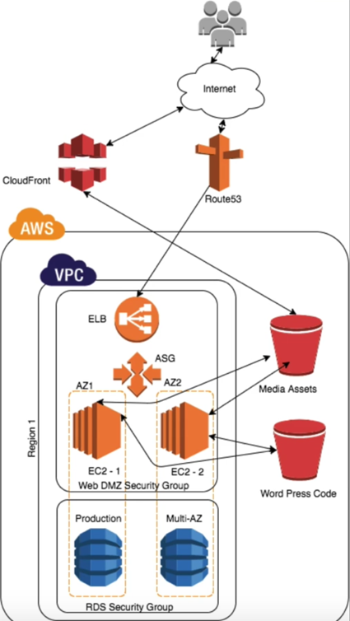

**Achieved desired benefits:**

* High Availability
* Fault Tolerance
* Resilience
* Auto Scaling
* Manage traffics